**1.2Sum返回这个array能不能pair成target的bool值**

use an **unordered_set** is enough

**2. 2Sum返回index, 只有一组答案**

**unordered_map** if(table.count(target - nums[i])) return {table[target - nums[i]] +1, i+1};

**3. 2Sum返回所有pair，Result 不含duplicate**

if it is need to be done in one pass, need another unordered_set to mark

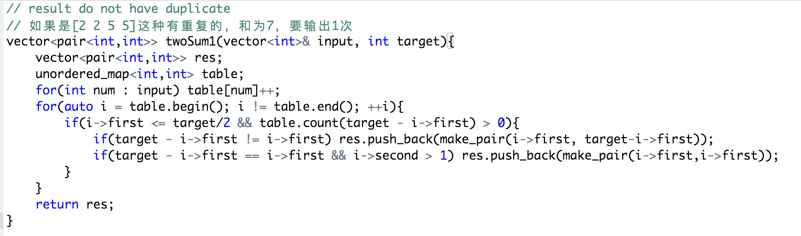

**4. 2Sum返回所有pair，Result含有duplicate，只要index不一样 都算unique**

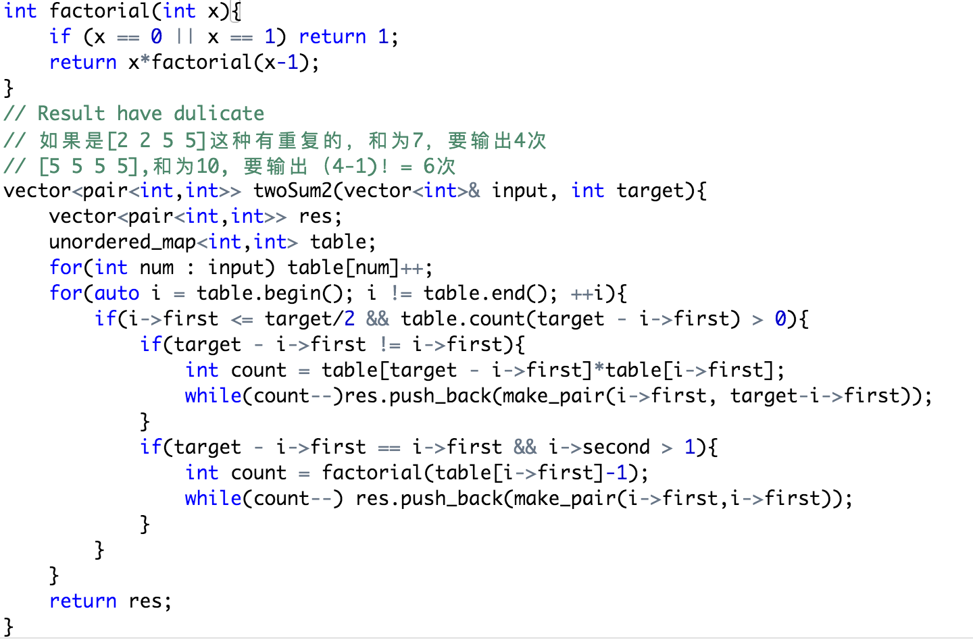

**5. 2Sum Sort Solution**

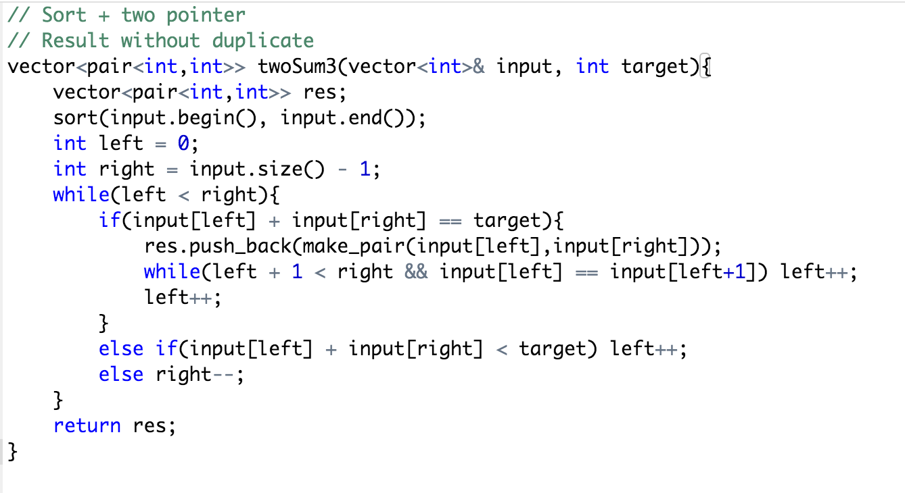

**6. 3Sum Result has dulicate**

**Sort + two pointer**

